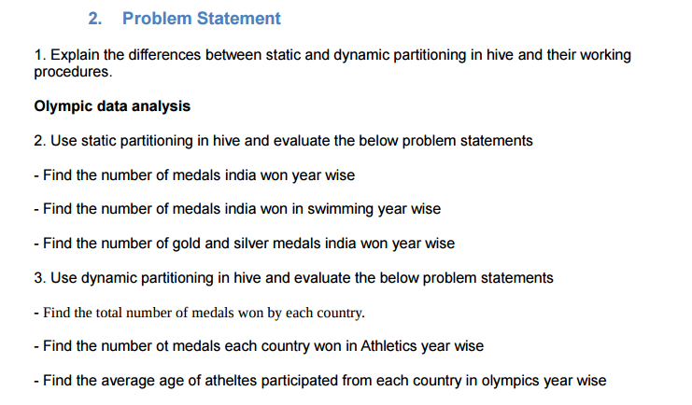

**1.) Explain the difference between Static and Dynamic Partitioning in Hive with an example.**

**Static Partition in Hive**

Insert input data files individually into a partition table is Static Partition Usually when loading files (big files) into Hive tables static partitions are preferred

Static Partition saves your time in loading data compared to dynamic partition You “statically” add a partition in table and move the file into the partition of the table.

We can alter the partition in static partition

You can get the partition column value form the filename, day of date etc without reading the whole big file. If you want to use Static partition in hive you should set property

set hive.mapred.mode = strict  
This property set by default in hive-site.xml Static partition is in Strict Mode You should use where clause to use limit in static partition You can perform Static partition on Hive Manage table or external table.

**Dynamic Partition in Hive**

single insert to partition table is known as dynamic partition

Usually dynamic partition load the data from non partitioned table

Dynamic Partition takes more time in loading data compared to static partition

When you have large data stored in a table then Dynamic partition is suitable.

If you want to partition number of column but you don’t know how many columns then also dynamic partition is suitable

Dynamic partition there is no required where clause to use limit. we can’t perform alter on Dynamic partition

You can perform dynamic partition on hive external table and managed table If you want to use Dynamic partition in hive then mode is in nonstrict mode Here is hive dynamic partition properties you should allow

SET hive.exec.dynamic.partition = true;

SET hive.exec.dynamic.partition.mode = nonstrict;

**2.) Use static partitioning in hive and evaluate the below problem statements –**

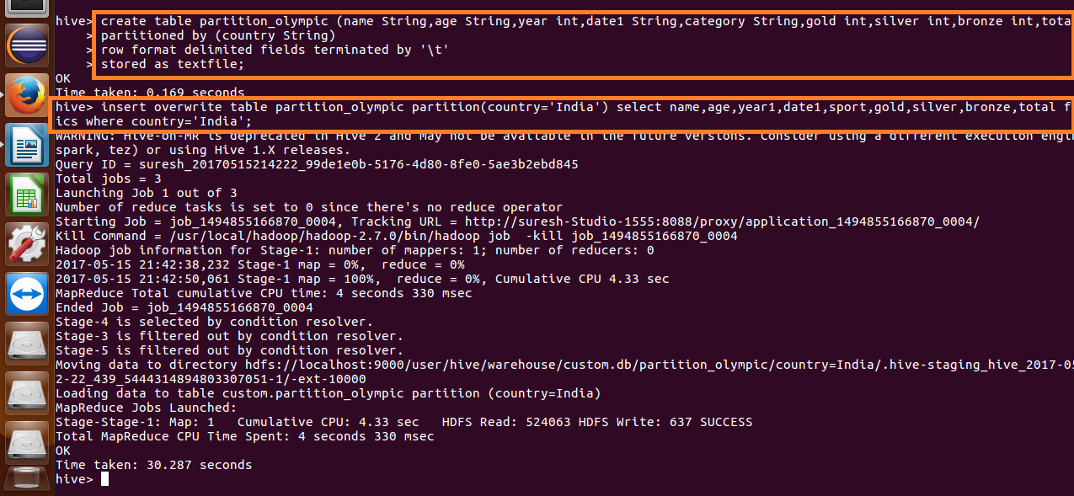

**Find the number of medals India won year wise**

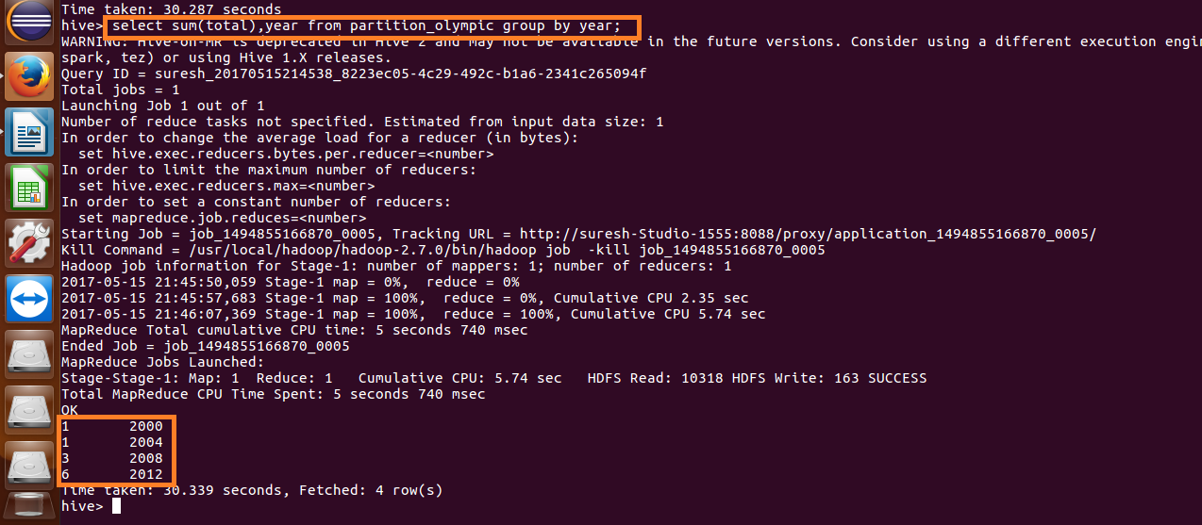

**Find the number of medals India won in swimming year wise**

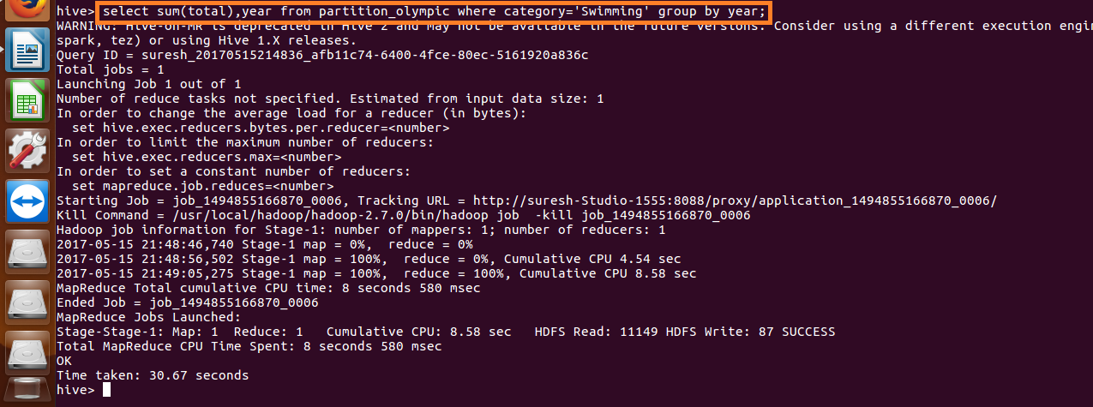

The above screenshot has no output as India hasn’t won any medal in swimming.

**Find the number of gold and silver medals India won year wise**

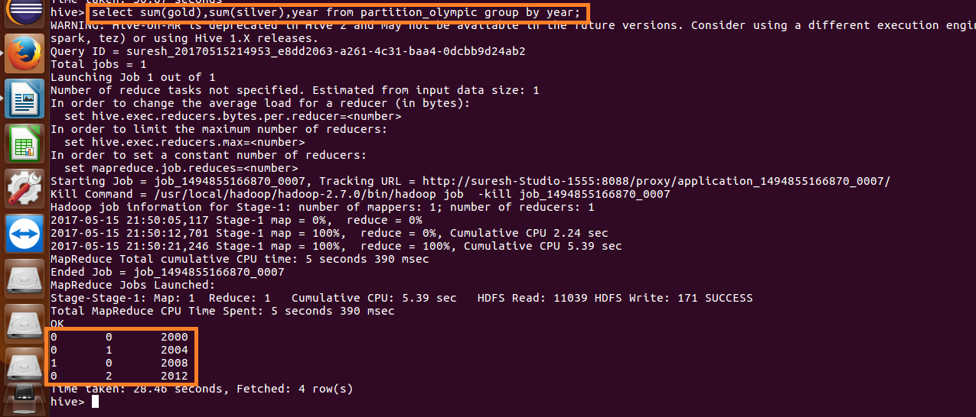

**3. Use dynamic partitioning in hive and evaluate the below problem statements - Find the total number of medals won by each country.**

**Setting the dynamic partitions.**



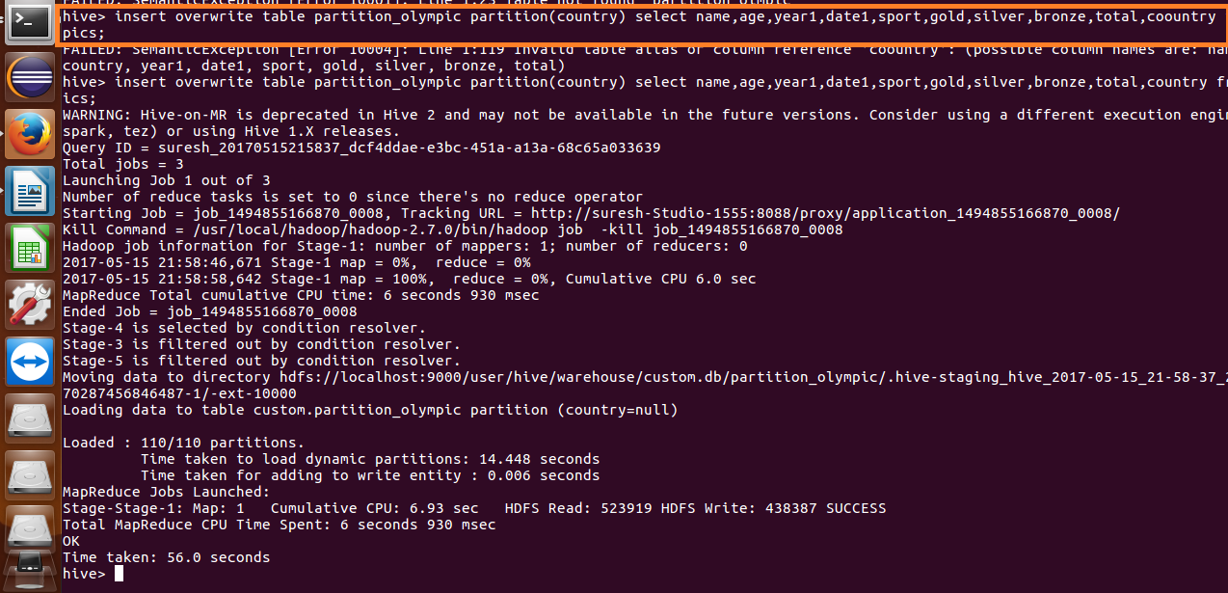

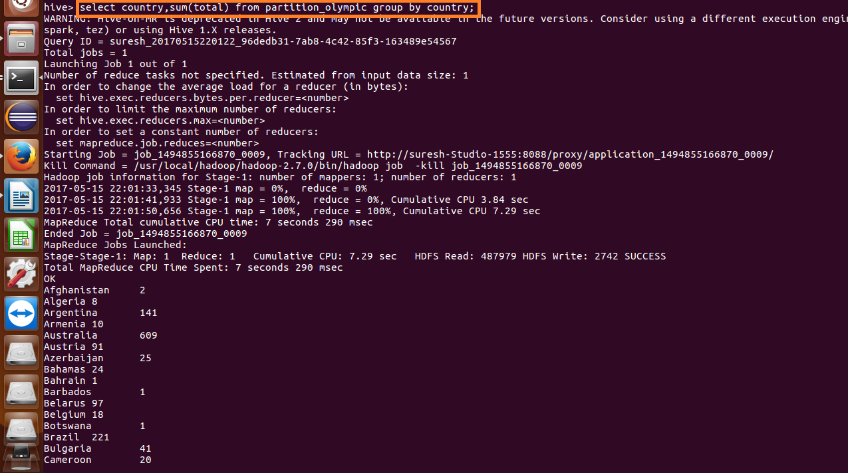

**Output:**

Afghanistan 2

Algeria 8

Argentina 141

Armenia 10

Australia 609

Austria 91

Azerbaijan 25

Bahamas 24

Bahrain 1

Barbados 1

Belarus 97

Belgium 18

Botswana 1

Brazil 221

Bulgaria 41

Cameroon 20

Canada 370

Chile 22

China 530

Chinese Taipei 20

Colombia 13

Costa Rica 2

Croatia 81

Cuba 188

Cyprus 1

Czech Republic 81

Denmark 89

Dominican Republic 5

Ecuador 1

Egypt 8

Eritrea 1

Estonia 18

Ethiopia 29

Finland 118

France 318

Gabon 1

Georgia 23

Germany 629

Great Britain 322

Greece 59

Grenada 1

Guatemala 1

Hong Kong 3

Hungary 145

Iceland 15

India 11

Indonesia 22

Iran 24

Ireland 9

Israel 4

Italy 331

Jamaica 80

Japan 282

Kazakhstan 42

Kenya 39

Kuwait 2

Kyrgyzstan 3

Latvia 17

Lithuania 30

Macedonia 1

Malaysia 3

Mauritius 1

Mexico 38

Moldova 5

Mongolia 10

Montenegro 14

Morocco 11

Mozambique 1

Netherlands 318

New Zealand 52

Nigeria 39

North Korea 21

Norway 192

Panama 1

Paraguay 17

Poland 80

Portugal 9

Puerto Rico 2

Qatar 3

Romania 123

Russia 768

Saudi Arabia 6

Serbia 31

Serbia and Montenegro 38

Singapore 7

Slovakia 35

Slovenia 25

South Africa 25

South Korea 308

Spain 205

Sri Lanka 1

Sudan 1

Sweden 181

Switzerland 93

Syria 1

Tajikistan 3

Thailand 18

Togo 1

Trinidad and Tobago 19

Tunisia 4

Turkey 28

Uganda 1

Ukraine 143

United Arab Emirates 1

United States 1312

Uruguay 1

Uzbekistan 19

Venezuela 4

Vietnam 2

Zimbabwe 7

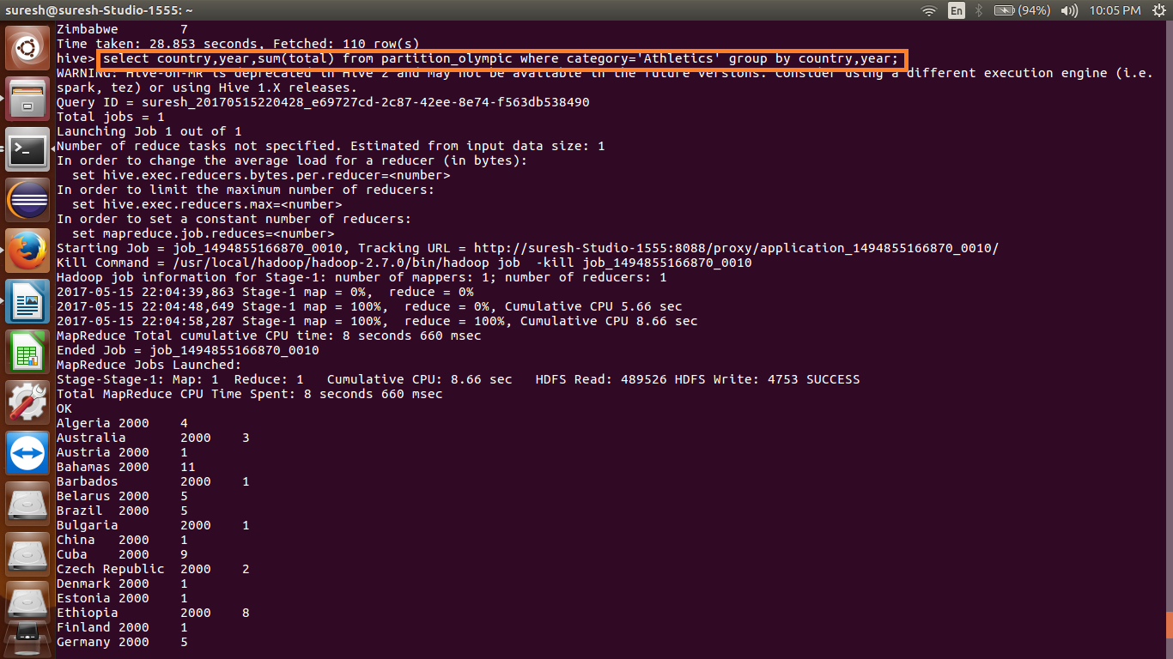

**Output 2:**

Algeria 2000 4

Australia 2000 3

Austria 2000 1

Bahamas 2000 11

Barbados 2000 1

Belarus 2000 5

Brazil 2000 5

Bulgaria 2000 1

China 2000 1

Cuba 2000 9

Czech Republic 2000 2

Denmark 2000 1

Estonia 2000 1

Ethiopia 2000 8

Finland 2000 1

Germany 2000 5

Great Britain 2000 6

Greece 2000 4

Iceland 2000 1

Ireland 2000 1

Italy 2000 2

Jamaica 2000 23

Japan 2000 1

Kazakhstan 2000 1

Kenya 2000 7

Latvia 2000 1

Lithuania 2000 1

Mexico 2000 2

Morocco 2000 4

Mozambique 2000 1

Nigeria 2000 7

Norway 2000 2

Poland 2000 4

Portugal 2000 1

Romania 2000 5

Russia 2000 18

Saudi Arabia 2000 1

South Africa 2000 3

Spain 2000 1

Sri Lanka 2000 1

Sweden 2000 1

Trinidad and Tobago 2000 2

Ukraine 2000 2

United States 2000 28

Australia 2004 6

Bahamas 2004 2

Belarus 2004 3

Brazil 2004 1

Cameroon 2004 1

China 2004 2

Cuba 2004 5

Czech Republic 2004 2

Denmark 2004 2

Dominican Republic 2004 1

Eritrea 2004 1

Estonia 2004 1

Ethiopia 2004 7

France 2004 5

Germany 2004 2

Great Britain 2004 7

Greece 2004 5

Hungary 2004 1

Italy 2004 3

Jamaica 2004 13

Japan 2004 2

Kazakhstan 2004 1

Kenya 2004 7

Latvia 2004 1

Lithuania 2004 2

Mexico 2004 1

Morocco 2004 3

Nigeria 2004 8

Norway 2004 1

Poland 2004 2

Portugal 2004 2

Romania 2004 3

Russia 2004 28

Slovenia 2004 1

South Africa 2004 2

Spain 2004 2

Sweden 2004 3

Turkey 2004 1

Ukraine 2004 4

United States 2004 39

Australia 2008 4

Bahamas 2008 7

Belarus 2008 7

Belgium 2008 5

Brazil 2008 1

Cameroon 2008 1

Canada 2008 1

China 2008 2

Croatia 2008 1

Cuba 2008 5

Czech Republic 2008 1

Ecuador 2008 1

Estonia 2008 1

Ethiopia 2008 7

Finland 2008 1

France 2008 2

Germany 2008 1

Great Britain 2008 4

Greece 2008 1

Italy 2008 2

Jamaica 2008 19

Japan 2008 4

Kenya 2008 14

Latvia 2008 1

Lithuania 2008 1

Morocco 2008 2

New Zealand 2008 2

Nigeria 2008 6

Norway 2008 2

Panama 2008 1

Poland 2008 2

Portugal 2008 1

Romania 2008 1

Russia 2008 29

Slovenia 2008 1

South Africa 2008 1

Sudan 2008 1

Trinidad and Tobago 2008 6

Turkey 2008 2

Ukraine 2008 5

United States 2008 32

Algeria 2012 1

Australia 2012 3

Bahamas 2012 4

Bahrain 2012 1

Botswana 2012 1

Canada 2012 1

China 2012 6

Colombia 2012 1

Croatia 2012 1

Cuba 2012 2

Czech Republic 2012 2

Dominican Republic 2012 2

Estonia 2012 1

Ethiopia 2012 7

Finland 2012 1

France 2012 2

Germany 2012 8

Great Britain 2012 6

Grenada 2012 1

Guatemala 2012 1

Hungary 2012 1

Iran 2012 1

Italy 2012 1

Jamaica 2012 25

Japan 2012 1

Kazakhstan 2012 1

Kenya 2012 11

Morocco 2012 1

New Zealand 2012 1

Poland 2012 2

Puerto Rico 2012 1

Qatar 2012 1

Russia 2012 23

Slovenia 2012 1

South Africa 2012 1

Trinidad and Tobago 2012 10

Tunisia 2012 1

Turkey 2012 2

Uganda 2012 1

Ukraine 2012 6

United States 2012 48

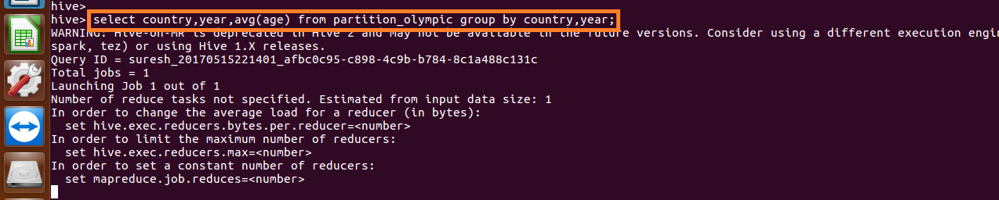

**Output 3:**

Algeria 2000 24.6

Argentina 2000 24.95

Armenia 2000 24.0

Australia 2000 26.614906832298136

Austria 2000 30.5

Azerbaijan 2000 28.333333333333332

Bahamas 2000 28.1

Barbados 2000 24.0

Belarus 2000 25.952380952380953

Belgium 2000 29.0

Brazil 2000 27.020833333333332

Bulgaria 2000 26.0

Cameroon 2000 21.11111111111111

Canada 2000 25.733333333333334

Chile 2000 23.235294117647058

China 2000 22.890625

Chinese Taipei 2000 24.2

Colombia 2000 35.0

Costa Rica 2000 27.0

Croatia 2000 25.7

Cuba 2000 27.815384615384616

Czech Republic 2000 28.11111111111111

Denmark 2000 27.2

Estonia 2000 27.666666666666668

Ethiopia 2000 24.285714285714285

Finland 2000 31.4

France 2000 27.39344262295082

Georgia 2000 26.5

Germany 2000 26.858490566037737

Great Britain 2000 28.641509433962263

Greece 2000 22.61111111111111

Hungary 2000 26.408163265306122

Iceland 2000 22.0

India 2000 25.0

Indonesia 2000 25.0

Iran 2000 22.75

Ireland 2000 30.0

Israel 2000 25.0

Italy 2000 28.866666666666667

Jamaica 2000 26.58823529411765

Japan 2000 24.926829268292682

Kazakhstan 2000 26.571428571428573

Kenya 2000 25.571428571428573

Kuwait 2000 33.0

Kyrgyzstan 2000 23.0

Latvia 2000 24.333333333333332

Lithuania 2000 26.647058823529413

Macedonia 2000 26.0

Mexico 2000 25.666666666666668

Moldova 2000 28.0

Morocco 2000 26.2

Mozambique 2000 27.0

Netherlands 2000 27.28358208955224

New Zealand 2000 32.5

Nigeria 2000 23.875

North Korea 2000 22.0

Norway 2000 27.19047619047619

Poland 2000 24.608695652173914

Portugal 2000 27.5

Qatar 2000 21.0

Romania 2000 25.228571428571428

Russia 2000 25.613095238095237

Saudi Arabia 2000 27.0

Serbia and Montenegro 2000 27.08

Slovakia 2000 22.0

Slovenia 2000 28.666666666666668

South Africa 2000 23.0

South Korea 2000 25.07246376811594

Spain 2000 25.61904761904762

Sri Lanka 2000 24.0

Sweden 2000 28.133333333333333

Switzerland 2000 31.076923076923077

Thailand 2000 26.0

Trinidad and Tobago 2000 26.0

Turkey 2000 25.6

Ukraine 2000 24.78125

United States 2000 26.299065420560748

Uruguay 2000 28.0

Uzbekistan 2000 23.25

Vietnam 2000 26.0

Australia 2002 27.5

Austria 2002 28.071428571428573

Belarus 2002 22.0

Bulgaria 2002 25.5

Canada 2002 28.5

China 2002 23.09090909090909

Croatia 2002 20.0

Czech Republic 2002 28.5

Estonia 2002 30.0

Finland 2002 23.333333333333332

France 2002 27.071428571428573

Germany 2002 27.29787234042553

Great Britain 2002 31.166666666666668

Italy 2002 27.11111111111111

Japan 2002 26.0

Netherlands 2002 26.833333333333332

Norway 2002 30.071428571428573

Poland 2002 24.0

Russia 2002 27.0

Slovenia 2002 23.25

South Korea 2002 17.4

Sweden 2002 23.0

Switzerland 2002 28.391304347826086

United States 2002 27.1125

Argentina 2004 26.46938775510204

Australia 2004 26.165413533834588

Austria 2004 29.428571428571427

Azerbaijan 2004 30.8

Bahamas 2004 28.0

Belarus 2004 26.647058823529413

Belgium 2004 27.0

Brazil 2004 27.425

Bulgaria 2004 23.6

Cameroon 2004 28.0

Canada 2004 27.5

Chile 2004 25.0

China 2004 23.761363636363637

Chinese Taipei 2004 21.77777777777778

Colombia 2004 35.0

Croatia 2004 26.714285714285715

Cuba 2004 26.177419354838708

Czech Republic 2004 24.25

Denmark 2004 27.310344827586206

Dominican Republic 2004 26.0

Egypt 2004 26.8

Eritrea 2004 22.0

Estonia 2004 34.0

Ethiopia 2004 22.666666666666668

Finland 2004 29.0

France 2004 27.1875

Georgia 2004 25.0

Germany 2004 27.431654676258994

Great Britain 2004 28.333333333333332

Greece 2004 26.903225806451612

Hong Kong 2004 28.5

Hungary 2004 27.210526315789473

India 2004 34.0

Indonesia 2004 24.6

Iran 2004 26.166666666666668

Israel 2004 27.5

Italy 2004 26.73267326732673

Jamaica 2004 26.363636363636363

Japan 2004 26.083333333333332

Kazakhstan 2004 24.625

Kenya 2004 23.857142857142858

Latvia 2004 26.0

Lithuania 2004 28.666666666666668

Mexico 2004 26.25

Mongolia 2004 20.0

Morocco 2004 27.5

Netherlands 2004 26.788732394366196

New Zealand 2004 27.166666666666668

Nigeria 2004 23.0

North Korea 2004 24.2

Norway 2004 26.166666666666668

Paraguay 2004 23.823529411764707

Poland 2004 26.8

Portugal 2004 25.333333333333332

Romania 2004 24.93103448275862

Russia 2004 26.363128491620113

Serbia and Montenegro 2004 27.153846153846153

Slovakia 2004 26.0

Slovenia 2004 26.8

South Africa 2004 24.625

South Korea 2004 24.959183673469386

Spain 2004 30.03846153846154

Sweden 2004 29.833333333333332

Switzerland 2004 28.285714285714285

Syria 2004 22.0

Thailand 2004 23.375

Trinidad and Tobago 2004 21.0

Turkey 2004 24.6

Ukraine 2004 26.893617021276597

United Arab Emirates 2004 40.0

United States 2004 26.166666666666668

Uzbekistan 2004 23.8

Venezuela 2004 26.5

Zimbabwe 2004 20.0

Australia 2006 26.0

Austria 2006 27.428571428571427

Belarus 2006 28.0

Bulgaria 2006 28.0

Canada 2006 27.57377049180328

China 2006 25.272727272727273

Croatia 2006 25.0

Czech Republic 2006 29.807692307692307

Estonia 2006 31.5

Finland 2006 28.3

France 2006 27.46153846153846

Germany 2006 28.605263157894736

Great Britain 2006 24.0

Italy 2006 29.666666666666668

Japan 2006 24.0

Latvia 2006 27.0

Netherlands 2006 27.444444444444443

Norway 2006 30.0625

Poland 2006 27.5

Russia 2006 27.914285714285715

Slovakia 2006 24.0

South Korea 2006 20.181818181818183

Sweden 2006 27.1864406779661

Switzerland 2006 28.263157894736842

Ukraine 2006 30.666666666666668

United States 2006 24.434782608695652

Afghanistan 2008 21.0

Algeria 2008 24.5

Argentina 2008 26.941176470588236

Armenia 2008 24.333333333333332

Australia 2008 26.25

Austria 2008 26.0

Azerbaijan 2008 24.285714285714285

Bahamas 2008 25.285714285714285

Belarus 2008 24.642857142857142

Belgium 2008 27.0

Brazil 2008 26.041095890410958

Bulgaria 2008 26.2

Cameroon 2008 32.0

Canada 2008 30.545454545454547

Chile 2008 28.0

China 2008 23.719745222929937

Chinese Taipei 2008 25.25

Colombia 2008 24.5

Croatia 2008 23.0

Cuba 2008 26.595744680851062

Czech Republic 2008 27.5

Denmark 2008 28.36842105263158

Dominican Republic 2008 26.0

Ecuador 2008 34.0

Egypt 2008 26.0

Estonia 2008 33.333333333333336

Ethiopia 2008 23.8

Finland 2008 30.4

France 2008 26.814285714285713

Georgia 2008 30.666666666666668

Germany 2008 27.22826086956522

Great Britain 2008 27.571428571428573

Greece 2008 28.0

Hungary 2008 27.782608695652176

Iceland 2008 27.785714285714285

India 2008 24.0

Indonesia 2008 23.0

Iran 2008 30.0

Ireland 2008 24.333333333333332

Israel 2008 21.0

Italy 2008 29.82051282051282

Jamaica 2008 23.533333333333335

Japan 2008 25.333333333333332

Kazakhstan 2008 23.76923076923077

Kenya 2008 23.785714285714285

Kyrgyzstan 2008 23.0

Latvia 2008 26.666666666666668

Lithuania 2008 31.4

Malaysia 2008 25.0

Mauritius 2008 30.0

Mexico 2008 23.5

Moldova 2008 25.0

Mongolia 2008 25.0

Morocco 2008 33.0

Netherlands 2008 26.6

New Zealand 2008 25.642857142857142

Nigeria 2008 21.652173913043477

North Korea 2008 23.333333333333332

Norway 2008 27.90909090909091

Panama 2008 25.0

Poland 2008 27.45

Portugal 2008 23.0

Romania 2008 26.210526315789473

Russia 2008 25.07246376811594

Serbia 2008 26.6

Singapore 2008 25.333333333333332

Slovakia 2008 29.4

Slovenia 2008 29.6

South Africa 2008 23.0

South Korea 2008 25.84722222222222

Spain 2008 27.772727272727273

Sudan 2008 23.0

Sweden 2008 32.714285714285715

Switzerland 2008 30.8

Tajikistan 2008 27.5

Thailand 2008 25.5

Togo 2008 27.0

Trinidad and Tobago 2008 24.4

Tunisia 2008 24.0

Turkey 2008 23.428571428571427

Ukraine 2008 25.451612903225808

United States 2008 26.03041825095057

Uzbekistan 2008 25.333333333333332

Venezuela 2008 24.0

Vietnam 2008 23.0

Zimbabwe 2008 24.0

Australia 2010 25.333333333333332

Austria 2010 27.333333333333332

Belarus 2010 27.666666666666668

Canada 2010 27.802325581395348

China 2010 26.0

Croatia 2010 26.0

Czech Republic 2010 27.5

Estonia 2010 32.0

Finland 2010 27.652173913043477

France 2010 26.09090909090909

Germany 2010 27.558139534883722

Great Britain 2010 27.0

Italy 2010 27.0

Japan 2010 25.0

Kazakhstan 2010 29.0

Latvia 2010 25.0

Netherlands 2010 25.666666666666668

Norway 2010 28.296296296296298

Poland 2010 26.4

Russia 2010 26.5

Slovakia 2010 28.5

Slovenia 2010 28.0

South Korea 2010 20.0

Sweden 2010 30.692307692307693

Switzerland 2010 28.636363636363637

United States 2010 25.202380952380953

Afghanistan 2012 25.0

Algeria 2012 24.0

Argentina 2012 25.894736842105264

Armenia 2012 23.333333333333332

Australia 2012 25.646464646464647

Azerbaijan 2012 23.4

Bahamas 2012 27.25

Bahrain 2012 27.0

Belarus 2012 25.0

Belgium 2012 26.0

Botswana 2012 18.0

Brazil 2012 26.071428571428573

Bulgaria 2012 29.0

Canada 2012 27.490909090909092

China 2012 23.75728155339806

Chinese Taipei 2012 23.0

Colombia 2012 24.625

Croatia 2012 27.542857142857144

Cuba 2012 24.857142857142858

Cyprus 2012 22.0

Czech Republic 2012 26.071428571428573

Denmark 2012 28.6875

Dominican Republic 2012 26.5

Egypt 2012 26.5

Estonia 2012 30.0

Ethiopia 2012 25.0

Finland 2012 26.2

France 2012 26.885714285714286

Gabon 2012 23.0

Georgia 2012 24.285714285714285

Germany 2012 27.57471264367816

Great Britain 2012 27.79824561403509

Greece 2012 24.333333333333332

Grenada 2012 19.0

Guatemala 2012 21.0

Hong Kong 2012 25.0

Hungary 2012 27.5

India 2012 27.333333333333332

Indonesia 2012 23.5

Iran 2012 24.916666666666668

Ireland 2012 25.2

Italy 2012 28.61904761904762

Jamaica 2012 25.444444444444443

Japan 2012 25.44736842105263

Kazakhstan 2012 26.153846153846153

Kenya 2012 26.5

Kuwait 2012 45.0

Latvia 2012 25.333333333333332

Lithuania 2012 23.0

Malaysia 2012 24.0

Mexico 2012 22.833333333333332

Moldova 2012 21.0

Mongolia 2012 25.2

Montenegro 2012 25.714285714285715

Morocco 2012 25.0

Netherlands 2012 27.46875

New Zealand 2012 28.51851851851852

North Korea 2012 23.0

Norway 2012 28.176470588235293

Poland 2012 26.5

Portugal 2012 24.0

Puerto Rico 2012 27.5

Qatar 2012 31.0

Romania 2012 23.857142857142858

Russia 2012 24.728682170542637

Saudi Arabia 2012 34.5

Serbia 2012 26.0

Singapore 2012 29.0

Slovakia 2012 30.4

Slovenia 2012 36.8

South Africa 2012 24.625

South Korea 2012 25.49122807017544

Spain 2012 26.16393442622951

Sweden 2012 30.40909090909091

Switzerland 2012 29.0

Tajikistan 2012 19.0

Thailand 2012 25.0

Trinidad and Tobago 2012 24.22222222222222

Tunisia 2012 28.0

Turkey 2012 22.0

Uganda 2012 23.0

Ukraine 2012 25.041666666666668

United States 2012 26.194174757281555

Uzbekistan 2012 28.0

Venezuela 2012 26.0